Versa64Cart User Guide
V0.1 Bwack 2017

Overview
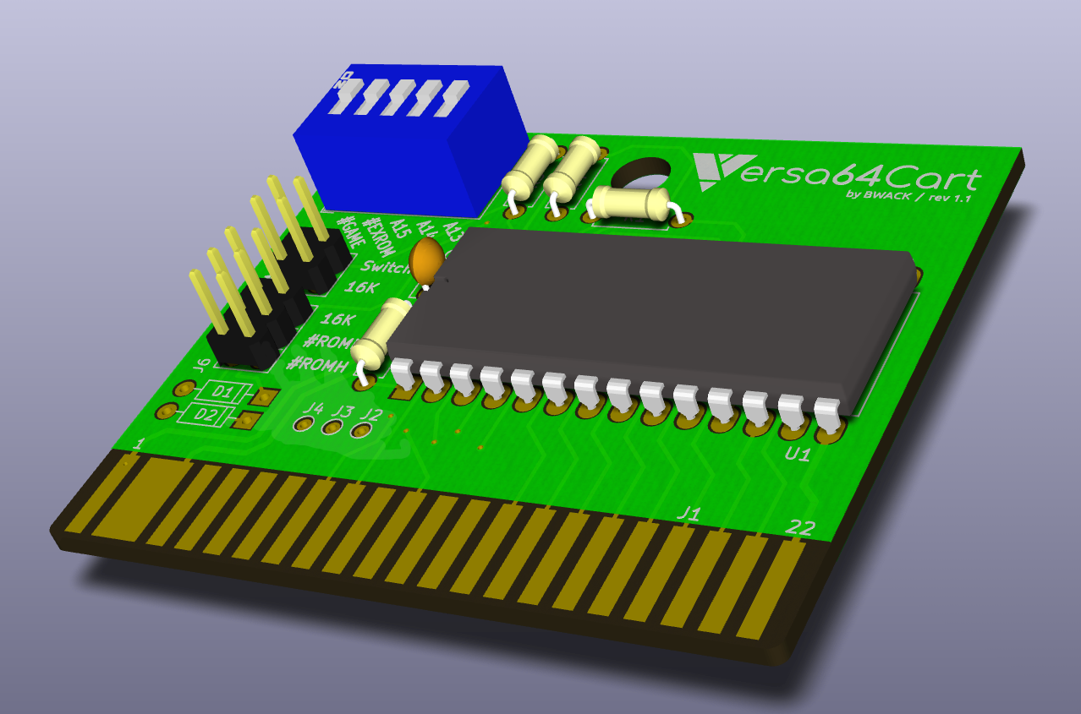Image 1: The Versa64Cart assembled
Supports 27C 64/128/256/512 roms.

Configurations
8k roms
See the #GAME and EXROM section.

16k roms
Solder in the two diodes for 16k rom images. #GAME and #EXROM pulled to 0V. Both jumpers must be on the 16k position. Because 16k cartridges normally had two 8k roms accessed with the signals ROML and ROMH, this single rom cartridge must OR them together.

It is possible to mix 16k and 8k rom images on a single cartridge. You can have a 16k and two 8k roms on a 27C256 EPROM. Use a dipswitch to set

Setting #GAME and #EXROM
These are signals you must set to map the rom into memory. They are routed to the C64 PLA.

8k: #EXROM=0, #GAME=1 : start $8000-$9FFF ROML(8k)
8k ultimax: #EXROM=1, #GAME=0 : start $E000-$FFFF ROML(8k) (replaces kernal ROM)
16k: #EXROM=0, #GAME=0 : start $8000-$BFFF (ROML) + $A000-$BFFF (ROMH)
16k ultimax: #EXROM=1, #GAME=0 : start $8000-$9FFF (ROML) + $E000-$FFFF (ROMH)

To find these settings in a .CRT file, use WinVICE's cartconv.exe tool with the -f option.

C:\WinVICE-2.4-x86>cartconv -f Wizard_of_Wor.crt
CRT Version: 1.0
Name: Wizard of Wor
Hardware ID: 0 (Generic Cartridge)
Mode: exrom: 0 game: 0 (16k Game)

offset sig type bank start size chunklen
$000040 CHIP ROM #000 $8000 $4000 $4010
Figure 1: Finding mode for Wizard of Wor in a CRT file.

Converting .CRT to .BIN
The eprom must be burned with the binary file. You can extract it using WinVICE's cartconv.exe tool with the

C:\WinVICE-2.4-x86>cartconv -i Wizard_of_Wor.crt -o wizardofwor.bin
Input file : Wizard_of_Wor.crt
Output file : wizardofwor.bin
Conversion from Generic Cartridge .crt to binary format successful.
Figure 2: Converting CRT to BIN for the EPROM.

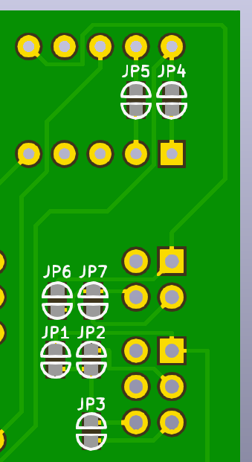
Solder Jumpers
In cases where you just want a fixed game or dead test cart, you don't need the jumper headers and the dipswitch.

JP5: #EXROM
JP4: #GAME

JP6: A13<->Switch
JP7: A13<->16K

JP1: 16K
JP2: #OE<->#ROML
JP3: #OE<->#ROMH

mode | #EXROM | #GAME | switch | 16K | 16K | #ROML | #ROMH
 | JP5 | JP4 | JP6 | JP7 | JP1 | JP2 | JP3
8k | x |  | x |  |  | x
8k ultimax |  | x | x |  |  |  | x
16k | x | x |  | x | x
16k ultimax |  | x |  | x | x

Bill of Materials (BOM)

